

CC-215-L: Database Systems Lab
Faculty of Computing & Information Technology

BS(IT&CS) Morning - Fall 2023
LAB – 10-EVEN
The objective of this lab is to:
- Practice PL/SQL
Course & Lab Instructor: Dr. Asif Sohail
Task 01: ___________________________ [10 Marks]
      - Write a PL/SQL code that takes two numbers as input from user and displayes there multiplication.
DECLARE
NUM1 NUMBER;
NUM2 NUMBER;
ANS NUMBER;
BEGIN
NUM1:=:NUM1;
NUM2:=:NUM2;
ANS:=NUM1*NUM2;
DBMS_OUTPUT.PUT_LINE(ANS);
END;
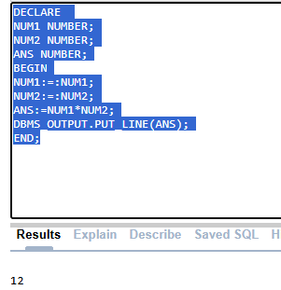
- Write a PL/SQL code to determine, weather the string is Palindrome or not. DON’T USE REVERSE() Function
DECLARE
STR VARCHAR2(100);
REVERSED_STR VARCHAR2(100) := '';
BEGIN
STR := :STR;
FOR I IN REVERSE 1..LENGTH(STR) LOOP
REVERSED_STR := REVERSED_STR || SUBSTR(STR, I, 1);
END LOOP;
IF UPPER(STR) = UPPER(REVERSED_STR) THEN
DBMS_OUTPUT.PUT_LINE('The string "' || STR || '" is a Palindrome.');
ELSE
DBMS_OUTPUT.PUT_LINE('The string "' || STR || '" is NOT a Palindrome.');
END IF;
END;

DECLARE
STR VARCHAR2(100);
IS_PALINDROME BOOLEAN := TRUE; BEGIN
STR := :STR;
FOR I IN 1..FLOOR(LENGTH(STR) / 2) LOOP
IF SUBSTR(STR, I, 1) != SUBSTR(STR, LENGTH(STR) - I + 1, 1) THEN
IS_PALINDROME := FALSE;
EXIT;
END IF;
END LOOP;
IF IS_PALINDROME THEN
DBMS_OUTPUT.PUT_LINE('The string "' || STR || '" is a Palindrome.');
ELSE
DBMS_OUTPUT.PUT_LINE('The string "' || STR || '" is NOT a Palindrome.');
END IF;
END;
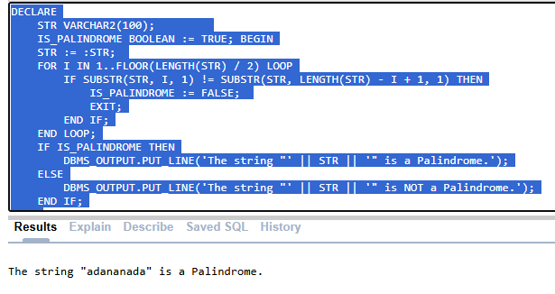
3. Write a PL/SQL block that takes EMPNO as input and display the name of the manager and its MGR number. “NO MANAGER FOUND’’ in case of manager does not exist.
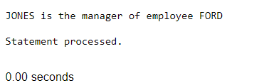
DECLARE
EMPLOYEENUM EMP.EMPNO%TYPE;
MANNAME EMP.ENAME%TYPE;
MANNUM EMP.MGR%TYPE;
EMPNAME EMP.ENAME%TYPE;
BEGIN
EMPLOYEENUM:=:EMPLOYEENUM;
SELECT M.EMPNO,M.ENAME,E.ENAME INTO MANNUM,MANNAME,EMPNAME
FROM EMP M
JOIN EMP E
ON E.MGR=M.EMPNO
WHERE E.EMPNO=EMPLOYEENUM;
DBMS_OUTPUT.PUT_LINE(MANNAME||' IS THE MANAGER OF '|| EMPNAME);
EXCEPTION
WHEN NO_DATA_FOUND THEN
DBMS_OUTPUT.PUT_LINE('NO MANAGER FOUND');
END;
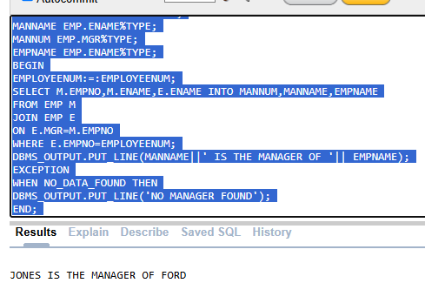
4. Write a program that retrieves sal of a certain employee and assign it to one out of three possible categories, "Low", "Average", or "High" on the basis of sal amount <1000, 1000 to 1500, and above 1500 respectively.
DECLARE
V_EMP EMP.EMPNO%TYPE;
V_SAL EMP.SAL%TYPE;
BEGIN
V_EMP:=:V_EMP;
SELECT SAL INTO V_SAL FROM EMP
WHERE V_EMP=EMPNO;
IF V_SAL <1000 THEN
DBMS_OUTPUT.PUT_LINE('LOW SAL');
ELSIF V_SAL BETWEEN 1000 AND 1500 THEN
DBMS_OUTPUT.PUT_LINE('AVERAGE SAL');
ELSE
DBMS_OUTPUT.PUT_LINE('HIGH SAL');
END IF;
END;
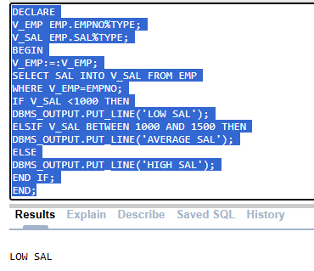
5. Write a PL/SQL program to compare an employee's salary with the average salary of employees in the same job and department, classifying it as "Below Average", "Above Average", or "Equal to Average".
DECLARE
V_SAL EMP.SAL%TYPE;
V_AVG EMP.SAL%TYPE;
V_EMPNO EMP.EMPNO%TYPE;
BEGIN
V_EMPNO:=:V_EMPNO;
SELECT SAL INTO V_SAL
FROM EMP
WHERE V_EMPNO = EMPNO;
SELECT AVG(SAL) INTO V_AVG
FROM EMP
WHERE JOB = (SELECT JOB FROM EMP WHERE V_EMPNO=EMPNO)
AND DEPTNO = (SELECT DEPTNO FROM EMP WHERE V_EMPNO=EMPNO);
IF V_SAL < V_AVG THEN
DBMS_OUTPUT.PUT_LINE('BELOW AVERAGE');
ELSIF V_SAL > V_AVG THEN
DBMS_OUTPUT.PUT_LINE('ABOVE AVERAGE');
ELSE
DBMS_OUTPUT.PUT_LINE('EQUAL TO AVERAGE');
END IF;
END;
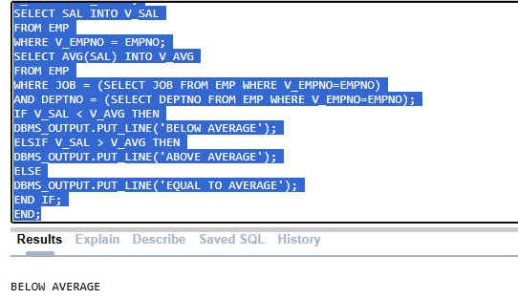
Task 02: ____________________________ [10 Marks]
- Write a PL/SQL program that displays the name of an employee in the following format: (3)
a)
B
L
A
K
E
DECLARE
V_ENAME EMP.ENAME%TYPE;
V_EMPNO EMP.EMPNO%TYPE;
BEGIN
V_EMPNO := :V_EMPNO;
SELECT ENAME INTO V_ENAME FROM EMP
WHERE EMPNO = V_EMPNO;
FOR I IN 1..LENGTH(V_ENAME) LOOP
DBMS_OUTPUT.PUT_LINE(SUBSTR(V_ENAME, I, 1));
END LOOP;
END;
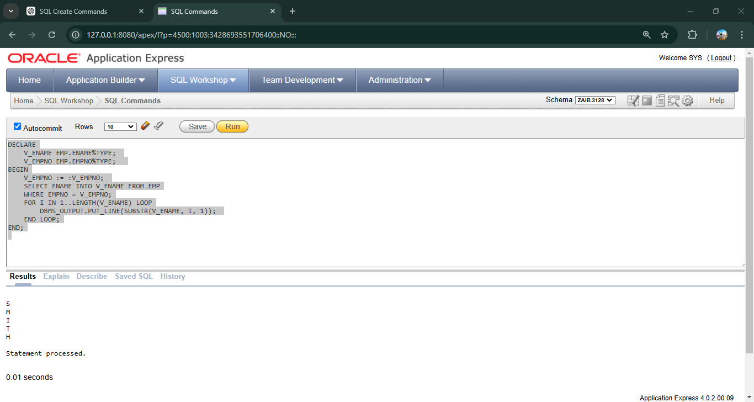
2. Write a PL/SQL block that counts the number of employees in each department and displays the department name along with the employee count. (2)
DECLARE
V_EMPCOUNT NUMBER;
V_DNAME DEPT.DNAME%TYPE;
BEGIN
SELECT DNAME,COUNT(EMPNO) INTO V_DNAME,V_EMPCOUNT FROM EMP
NATURAL JOIN DEPT
GROUP BY DNAME;
DBMS_OUTPUT.PUT_LINE(V_EMPCOUNT||' EMPLOYEES IN '||V_DNAME);
END;
3. Write a PL/SQL Block that takes two employee’s name as input and swap their salaries. YOU ARE ONLY ALLOWED TO USE ONE VARIABLE FOR SWAPPING SALARY. (2)
(Make sure to handle Exception)
DECLARE
V_ENAME1 EMP.ENAME%TYPE;
V_ENAME2 EMP.ENAME%TYPE;
V_SAL1 EMP.SAL%TYPE;
V_SAL2 EMP.SAL%TYPE;
BEGIN
V_ENAME1:=:V_ENAME1;
V_ENAME2:=:V_ENAME2;
SELECT SAL INTO V_SAL1 FROM EMP
WHERE V_ENAME1=ENAME;
SELECT SAL INTO V_SAL2 FROM EMP
WHERE V_ENAME2=ENAME;
DBMS_OUTPUT.PUT_LINE('BEFORE '||V_SAL1||' , '||V_SAL2);
V_SAL1:=V_SAL1+V_SAL2;
V_SAL2:=V_SAL1-V_SAL2;
V_SAL1:=V_SAL1-V_SAL2;
DBMS_OUTPUT.PUT_LINE('AFTER '||V_SAL1||' , '||V_SAL2);
END;

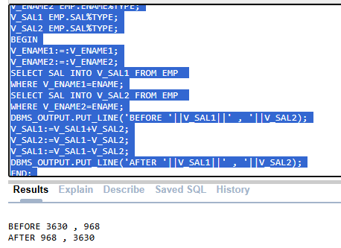
8. Write a PL/SQL program to calculate a running sum of employee salaries for a specific department using a cursor. Display each employee's name, salary, and the cumulative total. (3)
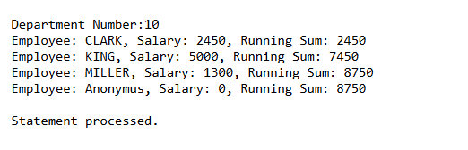
DECLARE
CURSOR RUNN_SAL IS
SELECT ENAME,SAL FROM EMP
WHERE DEPTNO=:DEPTNO;
RUN_SAL NUMBER := 0;
V_DEPTNO EMP.DEPTNO%TYPE:=:DEPTNO;
V_ENAME EMP.ENAME%TYPE;
V_SAL EMP.SAL%TYPE;
BEGIN
OPEN RUNN_SAL;
DBMS_OUTPUT.PUT_LINE('DEPARTMENT NO : '||V_DEPTNO);
LOOP
FETCH RUNN_SAL INTO V_ENAME,V_SAL;
RUN_SAL:=RUN_SAL+V_SAL;
EXIT WHEN RUNN_SAL%NOTFOUND;
DBMS_OUTPUT.PUT_LINE('EMPLOYEE : '||V_ENAME||' , SALARY '||V_SAL||' , RUNNING SALARY '||RUN_SAL);
END LOOP;
CLOSE RUNN_SAL;
END;
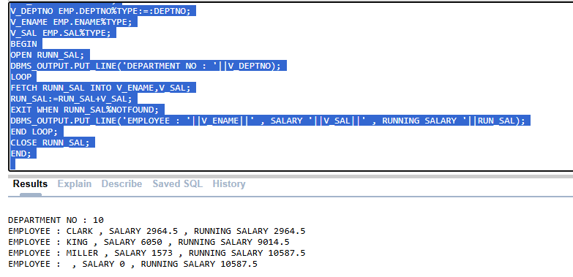
Task 03: ____________________________ [10 Marks]
1. Write a PL/SQL program that uses a cursor to calculate and display the total bonus allocated for each department based on employees' salaries. The bonus is calculated as 20% of the salary for employees with salaries above the department average, and 10% for others. Use a nested cursor to fetch employee details for each department and display their bonuses along with a department-wise total. (5)
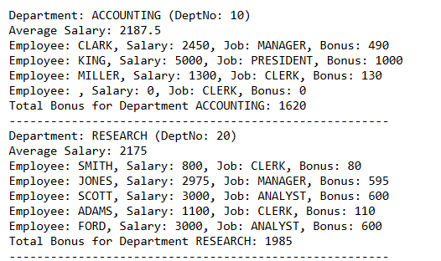
DECLARE
CURSOR DEPT_CURSOR IS
SELECT DEPTNO,DNAME FROM DEPT;
V_DEPTNO DEPT.DEPTNO%TYPE;
V_DNAME DEPT.DNAME%TYPE;
V_TOTAL NUMBER:=0;
CURSOR EMP_CURSOR IS
SELECT E.ENAME,E.SAL,E.JOB
FROM EMP E
WHERE E.DEPTNO = V_DEPTNO;
V_ENAME EMP.ENAME%TYPE;
V_SAL EMP.SAL%TYPE;
V_JOB EMP.JOB%TYPE;
V_DEPT_SAL NUMBER;
V_BONUS NUMBER;
BEGIN
OPEN DEPT_CURSOR;
LOOP
FETCH DEPT_CURSOR INTO V_DEPTNO ,V_DNAME;
EXIT WHEN DEPT_CURSOR%NOTFOUND;
SELECT AVG(SAL) INTO V_DEPT_SAL FROM EMP
WHERE V_DEPTNO = DEPTNO;
DBMS_OUTPUT.PUT_LINE('DEPARTMENT : '||V_DNAME||' (DEPTNO : ' ||V_DEPTNO||')');
DBMS_OUTPUT.PUT_LINE('AVERAGE SAL : '||V_DEPT_SAL);
OPEN EMP_CURSOR;
LOOP
FETCH EMP_CURSOR INTO V_ENAME,V_SAL,V_JOB;
EXIT WHEN EMP_CURSOR%NOTFOUND;
IF V_SAL > V_DEPT_SAL THEN
V_BONUS:=V_SAL*0.2;
ELSE
V_BONUS:=V_SAL*0.1;
END IF;
V_TOTAL:=V_TOTAL+V_BONUS;
DBMS_OUTPUT.PUT_LINE('EMPLOYEE: '||V_ENAME||', SALARY : '||V_SAL||', JOB : '||V_JOB||', BONUS: '||V_BONUS);
END LOOP;
DBMS_OUTPUT.PUT_LINE('TOTAL BONUS FOR DEPARTMENT '||V_DNAME||': '||V_TOTAL);
DBMS_OUTPUT.PUT_LINE('---------------------------------------');
CLOSE EMP_CURSOR;
END LOOP;
CLOSE DEPT_CURSOR;
END;
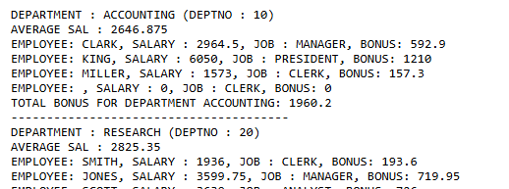
2. The company has decided to award bonus to its employees on the basis of the grade of the employee. The employees with grade 1,2,3,4,5 will be awarded a bonus amounting 50%,40%,30%,20%,10% of the sal respectively. Write a PL/SQL program that receives empno of an employee, and displays ename, grade, sal, and bonus. The program should also handle the exception of "NO_DATA_FOUND". (5)
DECLARE
V_EMPNO EMP.EMPNO%TYPE;
V_ENAME EMP.ENAME%TYPE;
V_GRADE SALGRADE.GRADE%TYPE;
V_SAL EMP.SAL%TYPE;
V_BONUS NUMBER;
BEGIN
V_EMPNO:=:V_EMPNO;
SELECT ENAME,S.GRADE,E.SAL INTO V_ENAME,V_GRADE,V_SAL FROM EMP E
JOIN SALGRADE S
ON E.SAL BETWEEN S.LOSAL AND S.HISAL
WHERE V_EMPNO=EMPNO;
CASE V_GRADE
WHEN 1 THEN
V_BONUS:= V_SAL*0.5;
WHEN 2 THEN
V_BONUS:= V_SAL*0.4;
WHEN 3 THEN
V_BONUS:= V_SAL*0.3;
WHEN 4 THEN
V_BONUS:= V_SAL*0.2;
WHEN 5 THEN
V_BONUS:= V_SAL*0.1;
END CASE;
DBMS_OUTPUT.PUT_LINE('NAME : '||V_ENAME||'--- SAL GRADE : '||V_GRADE||'---- SAL : '||V_SAL||'---- BONUS : '||V_BONUS);
EXCEPTION
WHEN NO_DATA_FOUND THEN
DBMS_OUTPUT.PUT_LINE('NO SUCH EMP EXISTS');
END;
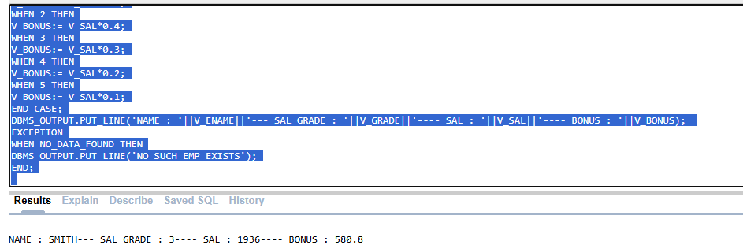
Task 04: ____________________________ [5 Marks]
VIVA VOCE

